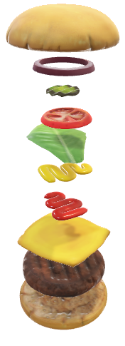Thembenhle Chauke

WEDE POE

GOOD Burgers

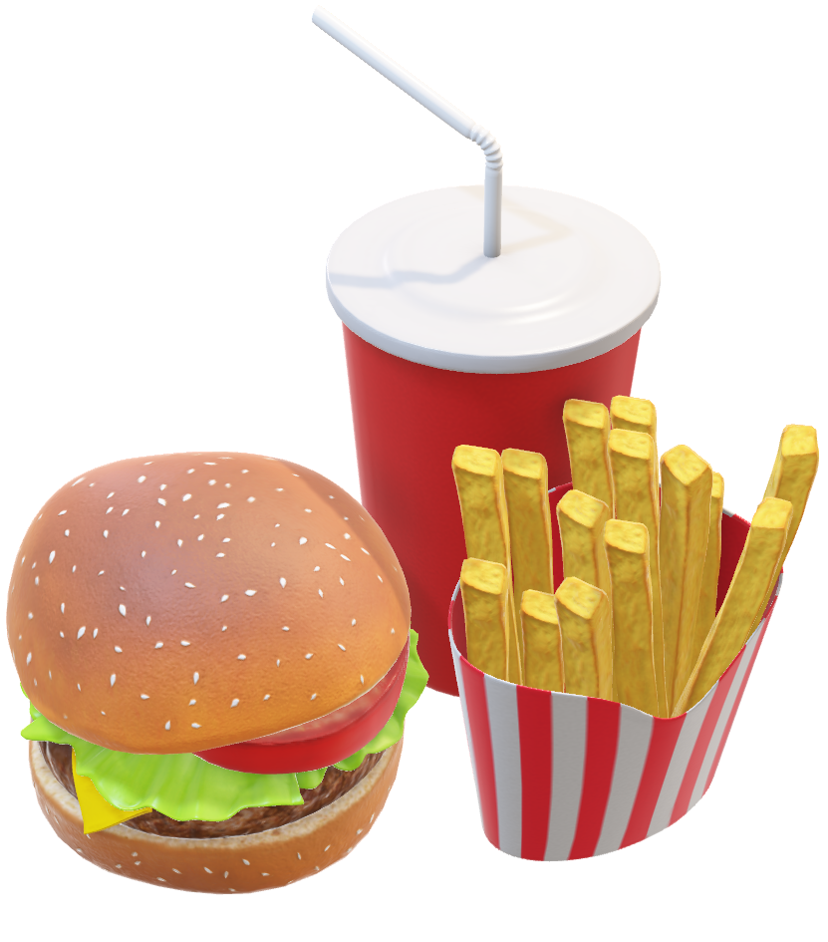i

Contents

Overview 3

Mission and vision 3

Target Audience 3

Goals 4

Essential Features 4

Design and Integration of user interface 4

Technical Requirements 6

Timeframe 6

Budget 6

# Overview

Name: Good Burger

Established:2015

Legally Established:2017

Good Burger was founded in 2015 as Insta-Burger King in Monstert Street, Mbombela by Keith J. Dhlamini and Matthew Sibuye. They developed a broiling system called the “Insta-Broiler,” which gave their burgers a unique flavor. However, the company struggled financially, leading to a sale in 2017 to Bongani Mazibuko and David Edgerton, two Mpumalanga-based entrepreneurs. They rebranded the chain as Good Burger and introduced flame grilling, which remains a key part of the brand’s identity. The burger joint was then moved from the street to Mbombela CDB because the visionaries thought big about the establishment and had big ambition about the restaurant and had long-term visions about the restaurant.

# Mission and vision

The official mission of Good Burger restaurant is to serve delicious, high-quality burgers made with fresh ingredients, cooked to perfection, and delivered with exceptional service. We strive to create a welcoming atmosphere where every guest feels at home, enjoying a meal that brings people together. We as good burger believe in satisfying our customers needs by serving them the best burgers in South African history and touching each soul with a tasteful burger. The vision of good burgers is to become the go-to burger destination, known for our commitment to quality, innovation, and community. We aim to expand our reach while maintaining our passion for great food, sustainability, and a memorable dining experience for every customer.

# Target Audience

Our Target audience is every customer whether young or old, poor, or rich, beautiful etc. We intend to target schools and offer them a supply of quality burgers that are affordable.

# Goals

# Essential Features

* Menu Display: A clear, visually appealing presentation of your offerings with images, descriptions, and prices.
* Online Ordering System: An integrated system for placing orders for delivery or pickup.
* Location and Hours: Easy-to-find details about the restaurant’s location, contact information, and operating hours.
* Reservations or Booking: If applicable, a feature of reserve tables or book events.
* Promotions and Loyalty Programs: Information on current deals, discounts, or a loyalty rewards system.

# Design and Integration of user interface

* Color Scheme: on this website I have applied a color that is orange because orange is a color that is eye catching towards customers who want to view the website.
* Typography: In my website I have used the Sans Serif because the font does not have the little strokes at the end and the reason why I used this type of font is because it is clean and modern and it is great for anyone who will view the site either using a phone or laptop
* Layout: The website design is based on the logo, and it was designed to be like it. For example, I have made a logo on the index page which has bold letters in the title of the page, and I have endorsed a color that is unique and different from other restaurants.
* User Experience: the navigation of the website is not a complicated one where users can move from one page to another by selecting either home, index, menu etc. On the website the other pages have the same color scheme which is orange

# Technical Requirements

The website has a google account name which you can type as Goodburger.co.za. The reason why I used this name is because it represents the site, and it is unique and has not been registered. I will use the framework of the like of Html to first develop the site and make some of the specific designs on C++ and java script.

# Timeframe

|  |  |  |  |  |  |
| --- | --- | --- | --- | --- | --- |
| 2025 March |  |  |  |  |  |
| From the 31st till the 7th of April will finish planning |  |  |  |  |  |
|  |  |  |  |  |  |  |  |
|  | 7-30 April 2035 |  | 7 May 2025 |  |  |
|  | I will do C++ AND Java for specifications |  | I will be done with everything needed |  |  |

# Budget

The budget of this website is plus minus R50000 because this was the given capital that was given to me.

# References

(Ryder)

<https://uk.pinterest.com/pin/triple-chicken-burger--447826756696187665/>

https://foodetccooks.com/wordpress/tag/homemade-double-cheeseburger/

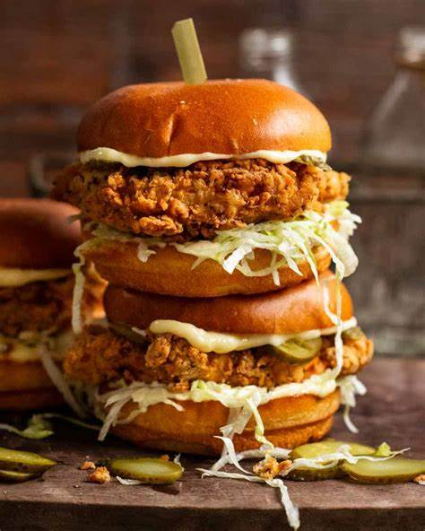

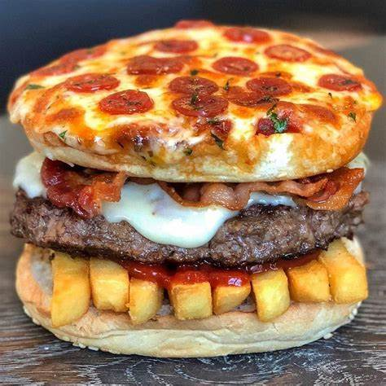

**Kazas ,A. Pizza burger Recipe**



